UCD School of Electrical, Electronic



& Communications Engineering

EEEN30110 Signals & Systems

Signed: _________________________________

Date: _________________________________

Lab 3 Signals and Systems Report

*Fergal Lonergan 13456938*

**Declaration: I declare that the work described in this report was done by the person named above, and that the description and comments in this report are my own work, except where otherwise acknowledged. I have read and understand the consequences of plagiarism as discussed in the EECE School Policy on Plagiarism, the UCD Plagiarism Policy and the UCD Briefing Document on Academic Integrity and Plagiarism. I also understand the definition of plagiarism.**

Lab 3 Signals and Systems Report

**Objective:**

To investigate applications of the Fourier Transform and filtering.

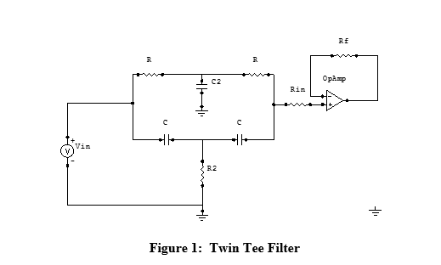

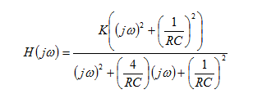

## Question 1



In order to this this we must take our formula for the transfer function above and set it equal to 0. After doing this we can then find our expression of $ω$ in terns of $K, R and C.$



$$0=\frac{K\left({\left(jω\right)}^{2}+{\left(\frac{1}{RC}\right)}^{2}\right)}{{\left(jw\right)}^{2}+\left(\frac{4}{RC}\right)\left(jω\right)+{\left(\frac{1}{RC}\right)}^{2}}$$

Therefore we can just let the top equal to 0 so:

$$0=K\left({\left(jω\right)}^{2}+{\left(\frac{1}{RC}\right)}^{2}\right)$$

And dividing both sides by K, squaring our terms and getting $ω$ on its own we get:

$$ω=\frac{1}{RC}$$

Question 2:



After importing the AudioData.wav file into MATLAB you just read the value for $f_{s}$ which is equal to 11025Hz.

## Question 3:

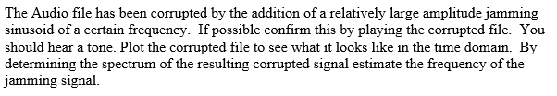

Using MATLAB I opened and played the sound using the sound() command. I then proceeded to plot the signal in the time domain (see Figure 1) and the in the frequency domain (see Figure 2). After analyzing Figure 2 further (see Figure 3) we can see that the jamming signal appears to be 400Hz.

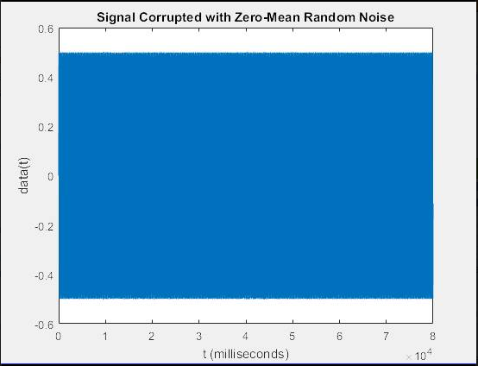

### Figure 1

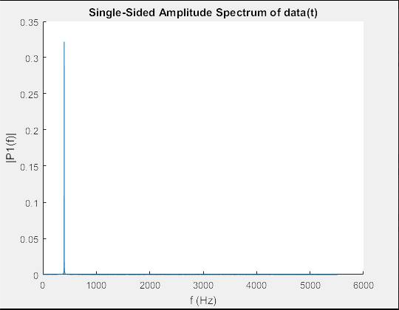

### Figure 2

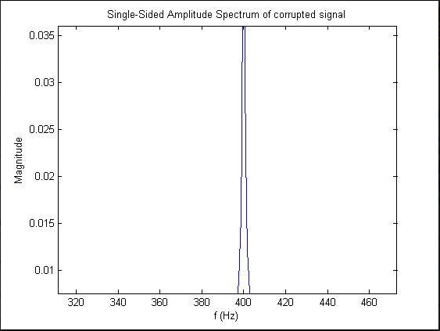

Figure 3

## Question 4:

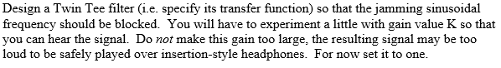

In order to design a Twin Tee filter that blocks out our jamming signal of 400Hz we must let our $\frac{1}{RC}$ be equal to $ω$ for that frequency. Therefore for every $\frac{1}{RC}$ we sub in $2π*400Hz$ or $800πHz$.

$$H(jω)=\frac{K\left({\left(jω\right)}^{2}+{\left(800πHz\right)}^{2}\right)}{{\left(jw\right)}^{2}+\left(4*800πHz\right)\left(jω\right)+{\left(800πHz\right)}^{2}}$$

$$H(s)=\frac{K\left({\left(s\right)}^{2}+{\left(800πHz\right)}^{2}\right)}{{\left(s\right)}^{2}+\left(4*800πHz\right)\left(s\right)+{\left(800πHz\right)}^{2}}$$

Then utilizing the OKAWA online Twin-Tee simulation tool I found resistance and capacitances that could be implemented to design our circuit.



|  |  |
| --- | --- |
| **COMPONENT** | **VALUE** |
| R | 5.6kΩ |
| $$R_{2}$$ | 1.5kΩ |
| C | 0.1µF |
| $$C_{2}$$ | 0.1µF |

$$R_{in} and R_{f} must be of a significant ratio so that the output signal is visible.$$

$$V_{in} is our input signal$$

We can now simulate the circuit and find that the center rejection frequency lies between:  
    f0 = 401.926926856[Hz]  
    f0 = 388.298301434[Hz]

As our circuit is supposed to reject frequencies of 400Hz this circuit is a very good model.

Therefore the poles and zeros of our circuit will be: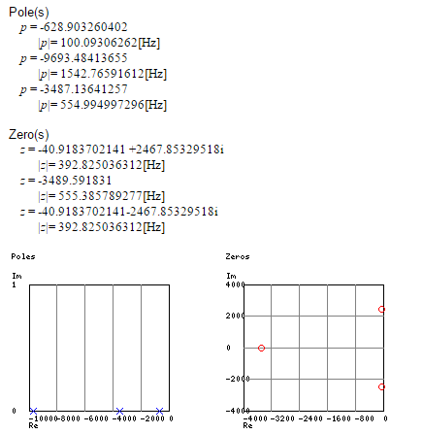

Therefore our system doesn’t oscillate.

And we get the following Bode diagrams:

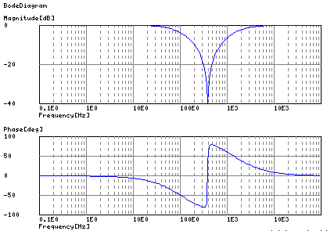

Finally it provides us with the following transient analysis:

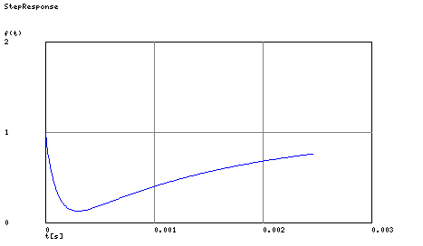

## Question 5:

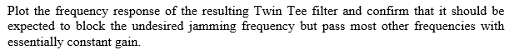

Then using MATLAB we plot the magnitude of the transfer function from Question 4 in relation to frequency we get the following graph (Figure 4) which shows the filtering of frequencies at 400Hz and the relative passing of all other frequencies.

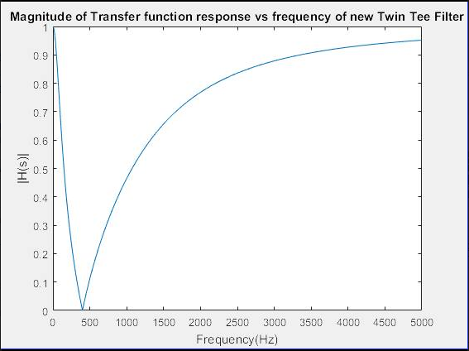

Figure 4

## Question 6:

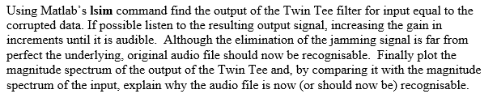

Now utilizing MATLAB’s lsim() command, I plot the output of my sound signal when passed through my filter. (See Figure 5) However after using the sound() command it is clear that the amplitude is much to low so I redefine my Transfer function and set K to be equal to 50 (See Figure 6) After then utilizing the lsim() and sound() commands again I am now able to hear Mike Meyers, in character as Austin Powers, say “Yeah Baby”.

### 

Figure 5

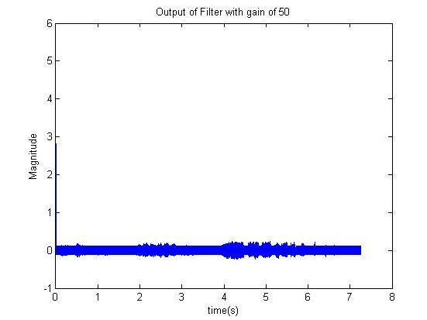

Figure 6

Finally I plot the magnitude spectrum of the output of my Twin Tee filter. (See Figure 7). I then plot the input versus the output (Figure 8). We can see that the filter has filtered the jamming signal greatly, from a magnitude of 0.16 to 0.069 and that in relation to the input signal the magnitude of the output signal at other frequencies appear to be greater than that of the input signal. This would explain why the sound clip is now audible where it wasn’t before.

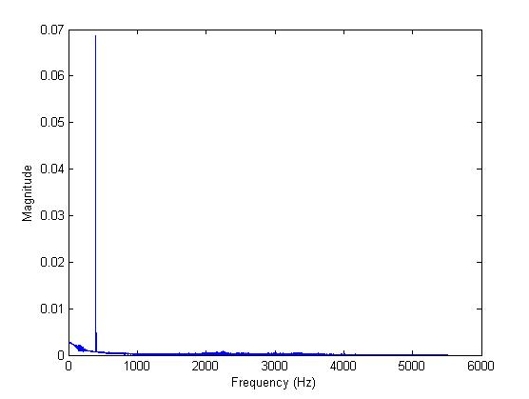

Figure 7

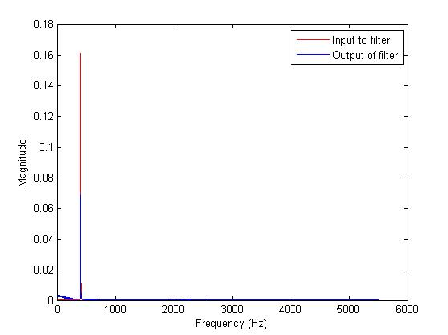

Figure 8